An Attitude of Gratitude

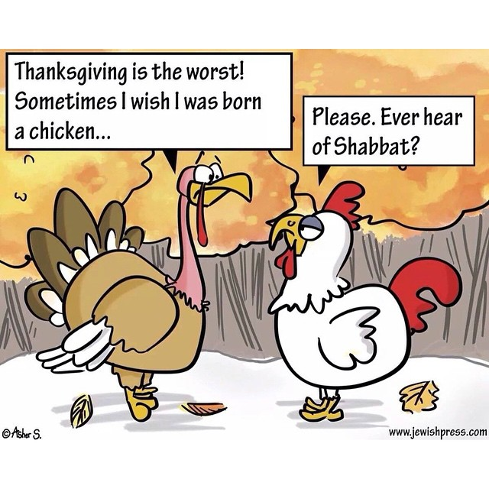
The Hebrew word for ‘Turkey’ is ‘Hodu’, which is also the Hebrew for ‘Thanks’!

Introduction
Talmud Shabbat 21b
What is Chanukah? Our Sages taught: On the twenty-fifth of Kislev, Chanukah is observed. This is for eight days, on which it is prohibited to eulogize or fast. For when the Greeks entered the Temple, they defiled all of the oil. And when the Hashmonaim rose to power and overcame them, they only found one container of oil sealed with the seal of the High Priest. It contained sufficient oil for only one day, but a miracle was performed with this oil and they lit from it for eight nights. In a different year they established and made these days a festival with Hallel (special songs of praise) and giving thanks.

Pirkei Avos (2:10)
Rabbi Yochanan (asked): Which is the worst trait? … said Rabbi Shimon: To borrow and not to repay…

Kitzur Shulchan Aruch (Code of Jewish Law) (1:2)
Upon waking one should say: “I am thankful before You, living and enduring King, for you have mercifully restored my soul within me. Great is Your faithfulness.”

Talmud Beitza 16a
One who gives a gift of a piece of bread to a child must inform his mother.
Rashi
He must make a sign, so that if the child eats it before he comes to his parents they’ll see it and will ask the child – who made you this sign? And he will say: So and so and he also gave me bread. Parents will find out that that person likes them and this will increase friendship between Jews.

Rabbi Yerucham Levovitz (1873-1936)
People think that being grateful is a wonderful trait and that being ungrateful is a flaw in aperson’s character. In reality, there are laws about gratitude and there is absolute obligation to recognize what the giver gave to a recipient and to thank him for it!

Mishnas Rabbi Eliezer, Chapter 7, p. 196
One who denies his friend’s kindness will eventually come to deny God’s kindness.

#1 Name 2 things that you are grateful for!

#2 Question: What are
(a) the positive outcomes of being a grateful person and
(b) the negative ones of being ungrateful?

#3 The Root of Ungratefulness
Summary of Torah Bereshis (Genesis) 11 1-5:
The descendants of Noah all decided to live together in the great valley of Babel. They appointed the first dictator, and all spoke the same language (Hebrew, according to tradition). They then decided to wage war on their Creator. "We will build a Tower to ascend Heaven and battle the Almighty!"

Torah Bereishis (Genesis) 11:5
“And the Lord descended to see the city and the tower that the sons of man (Adam) had built.”
Rashi
The sons of man (Adam): But the sons of whom else [could they have been]? The sons of donkeys and camels? Rather, [this refers to] the sons of the first man, who was ungrateful and said (above 3:12):“The woman whom You gave [to be] with me.” These, too, were ungrateful in rebelling against the One Who lavished goodness upon them, and saved them from the Flood.

Question: Why are people by nature ungrateful?
If being grateful makes sense, and it is even praiseworthy, why then do most people have difficulty with it?

#4
Talmud Yevamos 63a
Rabbi Chiya's wife used to pain him. When he would find something (that she would like), he would wrap it in his turban and bring it for her. Rav: “Why do you do this? She pains you!” Rabbi Chiya: “It suffices for us that our wives raise our children and save us from sin.”
(By taking care of herself, applying makeup and looking beautiful, her husband will not have any thoughts about other women besides his wife.)

Question: It makes sense that Rabbi Chiya should be grateful to his wife for raising their children – it is hard work. But why does he feel the need to show his appreciation for her “saving him from sin”? She wants to look beautiful – it is for herself even more than for her husband!

#5
Talmud Bava Kamma 92b
If you drank from a pit, do not throw dirt in it.

Torah Shemos (Exodus) 7:19
The Lord said to Moses, "Say to Aaron, 'Take your staff and stretch forth your hand over the waters of Egypt, over their rivers, over their canals, over their ponds, and over all their bodies of water, and they will become blood, and there will be blood throughout the entire land of Egypt, even in wood and in stone.' "
Rashi
Say to Aaron: Since the Nile protected Moses when he was cast into it, it therefore was not smitten by him, neither with blood nor with frogs, but was smitten by Aaron.

Torah Shemos (Exodus) 8:12
The Lord said to Moses, "Say to Aaron, 'Stretch forth your staff and strike the dust of the earth, and it shall become lice throughout the entire land of Egypt.' "
Rashi
Say to Aaron: It was inappropriate for the dust to be smitten through Moses since it protected him when he slew the Egyptian and had hidden him in the sand. Therefore, it was smitten through Aaron instead.

Question: Why do we have to show our gratitude to inanimate objects who don’t need it or understand it?

#6 The Reach of our Obligation to be Grateful.
Shmos Rabbah (1:32)
A wild donkey bit a man. He escaped from the donkey into a river. Suddenly, he saw a child that was drowning. The man extended his hand and saved the child. The child told him: ‘If not for you, I would have died.” The man told him: “It is not me who saved you, it was the wild donkey that bit me and forced me to run away from him.”

What are your thoughts about this?

#7 Question:
How would you apply these concepts and your findings to your own life and personality?

